# PART D – SOFTWARE DESIGN DESCRIPTION

## DESIGN OVERVIEW

The intention of this document is to specify the design of the OATS system in sufficient detail to adequately describe how the system implements the requirements. This document will contain information about the system architecture, detailed description of components, data structures, user interface design and so on. This is to give the reader, a better understanding of the design process and procedure for this web application. This document is also used by the developers as a “template” in order to continue with the coding.

Overview of document:

* The first section describes the introduction of document.
* The second section describes the system architecture.
* The third section gives the component diagrams that describe the connection and integration of the system.
* The fourth section consists of detailed description of the modules or components of the system.
* The fifth section brings out the sequence diagrams that describe the order of actions.
* The sixth section provides the information of user interface design.
* The seventh section gives the detailed database design.

## SYSTEM ARCHITECTURAL DESIGN

### CHOICE OF SYSTEM ARCHITECTURE

The architecture used for this web application is the Model View Controller Architecture implemented in Three Layer Architecture.



The Three‐layer architecture has three different layers being User Interface Layer, Business Logic Layer, and Data Layer – Entity Framework.

* The User Interface Layer (client layer) is basically the most upper level of the structure which is used to present the information on the client machine. It is a combination of view and controller.
* The Business Logic Layer is the layer that controls all application’s functionalities by performing detailed processing. The layer would use a Model in order to handle business logic request from View and Controller.
* The Data Layer is the layer that uses Entity Framework – an object relational mapper work with relational data using domain specific objects.

### DISCUSSION OF ALTERNATIVE DESIGNS

N/A

### DESCRIPTION OF SYSTEM INTERFACE

N/A

## CLASS DIAGRAM

### CLASS DIAGRAM

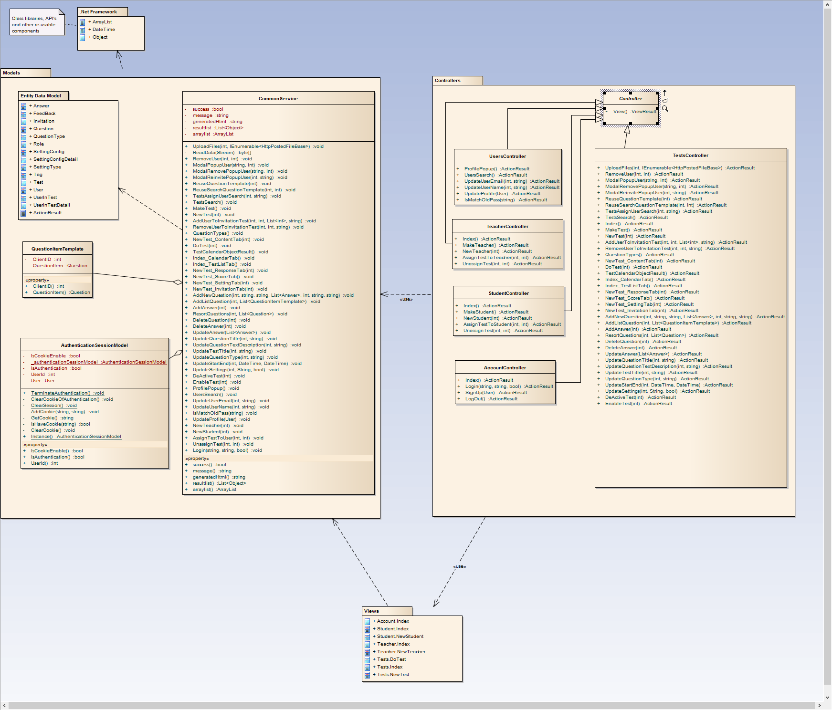

### CLASS DIAGRAM EXPLANATION

* The User Object is the actual user information stored on the database. It includes all information submitted when the user registered or update personal account, go along with various functions to load user information, interact with the system and other users.
* The Teacher and Student are objects extended from User.
* Entity Data Model contains classes these were generated by Entity Framework in order to mapping to Database.
* AuthenticationSessionModel is for user authentication in system. Implement by cookies (if enabled) and session.
* CommonService is the object responsible for handle all business logic from controller and view.
* CommonService have dependency on Entity Data Model classes. It can access AuthenticationSessionModel object to checking users and get information about users. It has many QuestionItemTemplate as template class when import a list of questions from plain text files.
* TestsController is responsible for manage logics about tests receive from views (user inputs). UserController and AccountController are used for handle about user authentication and common user information.
* TeacherController and StudentController handle requests about assign created tests for teachers or students
* Views are responsible for display information and update model.

### ALGORITHMS

* Create Test



* Do Test



* Invitation



## SEQUENCE DIAGRAM

### LOGIN SEQUENCE



### REGISTER SEQUENCE



### SEARCH TESTS SEQUENCE



### CREATE TEST SEQUENCE



### DO TEST SEQUENCE



### DUPLICATE QUESTION SEQUENCE



### REUSE QUESTION SEQUENCE



### IMPORT QUESTIONS SEQUENCE



### REMOVE QUESTION SEQUENCE



### INVITATION SEQUENCE



## USER INTERFACE DESIGN

### LOGIN SCREEN

#### Screen Images C:\Users\THIBT\Desktop\11.png

#### Objects and Actions

##### Data fields - Login screen

|  |  |  |  |  |  |  |
| --- | --- | --- | --- | --- | --- | --- |
| **Field No** | **Field name** | **Type** | **Mandatory** | **Data type** | **Max length** | **Description** |
| 1 | Email Address | Textbox | Y | String |  | Contain email address to login |
| 3 | Password | Password | Y | String |  | Contain password to login |

##### Actions – Register screen

|  |  |  |  |  |  |
| --- | --- | --- | --- | --- | --- |
| **Field No** | **Field name** | **Type** | **Action** | **Description** | **Validation** |
| 2 | Remember Email | Checkbox | On click | Remember email address for next login |  |
| 4 | Login | Button | On click | Send inputted username and password to server |  |
| 5 | Forget password | Link | On click | Forward to Forget Password Screen |  |

### REGISTER SCREEN

#### Screen ImagesC:\Users\THIBT\Desktop\10.png

#### Objects and Actions

##### Data fields - Register screen

|  |  |  |  |  |  |  |
| --- | --- | --- | --- | --- | --- | --- |
| **Field No** | **Field name** | **Type** | **Mandatory** | **Data type** | **Max length** | **Description** |
| 1 | First Name | Textbox | N | String | 20 | Contain first name to register |
| 2 | Last Name | Textbox | N | String | 20 | Contain first name to register |
| 3 | Email Address | Textbox | Y | String | 50 | Contain email address to register |
| 4 | Password | Textbox | Y | String | 50 | Contain password to register |
| 5 | Confirm Password | Textbox | Y | String | 50 | Contain the confirm password |
| 6 | Phone Number | Textbox | N | Number | 25 | Contain user's phone number |
| 7 | Country | Textbox | N | String | 50 | Contain user's country |

##### Actions – Register screen

|  |  |  |  |  |  |
| --- | --- | --- | --- | --- | --- |
| **Field No** | **Field name** | **Type** | **Action** | **Description** | **Validation** |
| 3 | Email Checking | Textbox | On leave | Check the inputted email | Must in the right format and |
| 4 | Password Checking | Textbox | On leave | Check the inputted password | Must be in range of [8,50] characters |
| 5 | Confirm Password | Textbox | On leave | Check the inputted text | Must matched with the inputted password |
| 8 | Registration Confirm | Checkbox | On click | Confirm that user has read and understand the policy | Has been Checked to signup |
| 9 | Signup | Button | On click | Submit inputted data to server | Inputted data must be valid |

### HOMEPAGE SCREEN

#### Screen Images

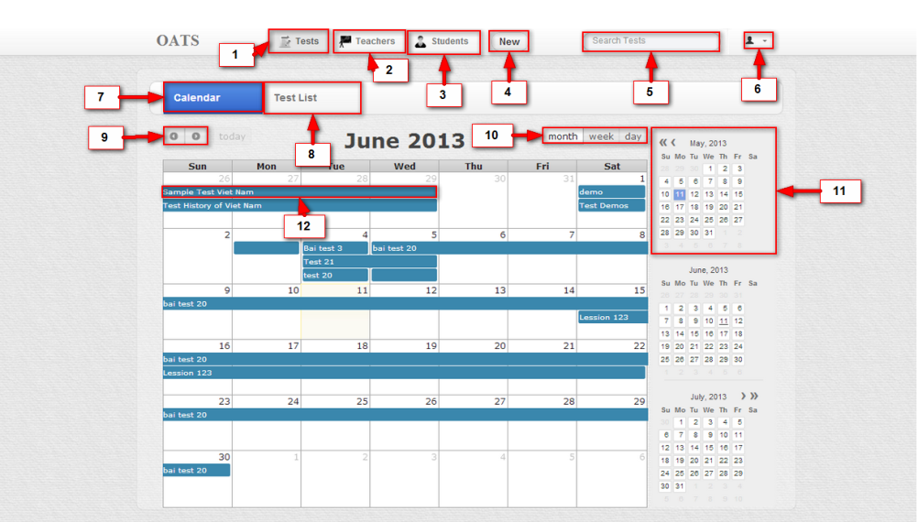

#### Objects and Actions

##### Data fields – Home page screen

|  |  |  |  |  |  |  |
| --- | --- | --- | --- | --- | --- | --- |
| **Field No** | **Field name** | **Type** | **Mandatory** | **Data type** | **Max length** | **Description** |
| 5 | Search Condition | Textbox | N | String | 50 | Contain search condition to find the test |

##### Actions – Home page screen

|  |  |  |  |  |  |
| --- | --- | --- | --- | --- | --- |
| **Field No** | **Field name** | **Type** | **Action** | **Description** | **Validation** |
| 1 | Tests Tab | Textbox | On click | Forward to Test page |  |
| 2 | Teachers Tab | Button | On click | Forward to Teacher page |  |
| 4 | New | Button | On click | Forward to Test page to allow user create new test |  |
| 5 | Search Condition | Textbox | submit | Send inputted text to server to search test |  |
| 6 | User menu setting | Menu | On click | Forward to "Account setting" screen |  |
| 7 | Calendar | Menu | On click | Forward to "Calendar" screen |  |
| 8 | Test list | Menu | On click | Forward to "Test list" screen |  |
| 9 | Move | Button | On click | Show next or previous month ( week or date ) with available Tests list |  |
| 10 | List Show | Button | On click | Show available tests on the month, week or date |  |
| 11 | Month View | Table | On click | Choose the month to show off |  |
| 12 | Test information | Label | On click | N/A |  |

### TEST LIST SCREEN

#### Screen Images

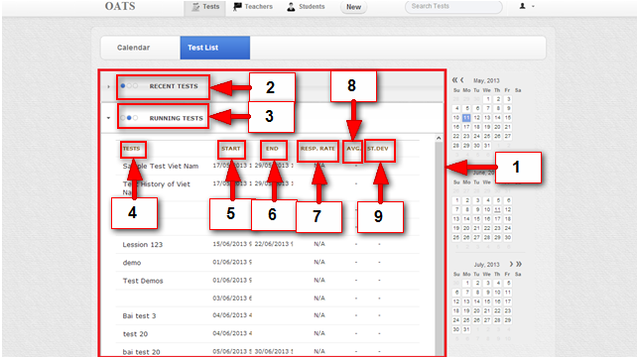

#### Objects and Actions

##### Data fields – Select Language screen

|  |  |  |  |  |  |  |
| --- | --- | --- | --- | --- | --- | --- |
| **Field No** | **Field name** | **Type** | **Mandatory** | **Data type** | **Max length** | **Description** |
| 1 | Test All | Text |  | String |  | List of available Tests |

##### Actions – Select language screen

|  |  |  |  |  |  |
| --- | --- | --- | --- | --- | --- |
| **Field No** | **Field name** | **Type** | **Action** | **Description** | **Validation** |
| 2 | Recent Tests | Label | On click | Show/Hide list of recent test (no longer open to student to take it) |  |
| 3 | Running Tests | Label | On click | Show/Hide list of running test (currently open to assigned students to take them) |  |
| 4 | Test Name | Text |  | Name of Test |  |
| 5 | Start Date | Date time |  | Start date of Test |  |
| 6 | End Date | Date time |  | End date of Test |  |
| 7 | Respond Rate | Text |  |  |  |
| 8 | Average | Text |  |  |  |
| 9 | <ST.DEV> | Text |  |  |  |

### TESTS SEARCH SCREEN

#### Screen Images

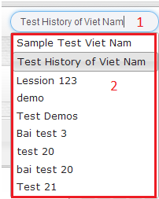

#### Objects and Actions

##### Data fields – Friend List screen

|  |  |  |  |  |  |  |
| --- | --- | --- | --- | --- | --- | --- |
| **Field No** | **Field name** | **Type** | **Mandatory** | **Data type** | **Max length** | **Description** |
| 1 | Search Condition | Textbox | N | String |  | List all available Tests |

##### Actions – Friend List screen

|  |  |  |  |  |  |
| --- | --- | --- | --- | --- | --- |
| **Field No** | **Field name** | **Type** | **Action** | **Description** | **Validation** |
| 2 | TestsPopUp | Pop-up | On click | Forward to page of this Test |  |

### NEW TESTS SCREEN

#### Screen Images

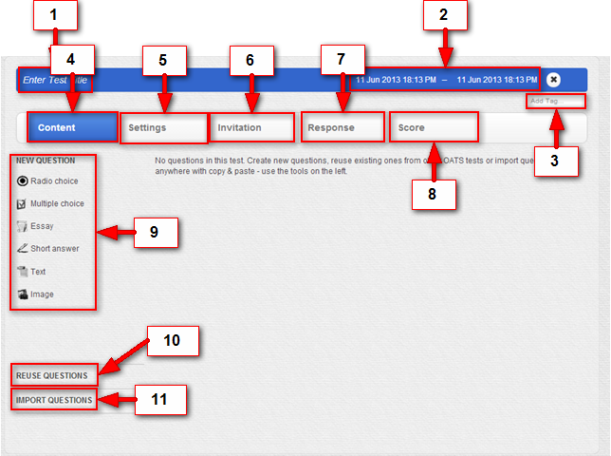

#### Objects and Actions

##### Data fields – Recent courses screen

|  |  |  |  |  |  |  |
| --- | --- | --- | --- | --- | --- | --- |
| **Field No** | **Field name** | **Type** | **Mandatory** | **Data type** | **Max length** | **Description** |
| 1 | Test Title | Textbox | Y | String | 50 | Enter name for current Test |
| 2 | Available Date | Textbox | N | Date time |  | Set time for current Test |
| 3 | Tag | Textbox | N | String |  | Add tag for current Test |

##### Actions – Recent courses screen

|  |  |  |  |  |  |
| --- | --- | --- | --- | --- | --- |
| **Field No** | **Field name** | **Type** | **Action** | **Description** | **Validation** |
| 4 | Content | Label | On click | Allow user to Create content of test |  |
| 5 | Setting | Label | On click |  |  |
| 6 | Invitation | Label | On click | Allow invite, re-invite or remove invitations to a user. |  |
| 7 | Response | Label | On click |  |  |
| 8 | Score | Label | On click | Forward to selected class’ page |  |
| 9 | New Question | Label | On click | Allow user create question with these kinds. |  |
| 10 | Reuse Question | Label | On click | Allow user reuse question that’s already created. |  |
| 11 | Import Question | Label | On click | Allow user import questions from other sources. |  |

##### C:\Users\THIBT\Desktop\Images For Screen\6.2.png

##### Data fields – Reuse Question screen

|  |  |  |  |  |  |  |
| --- | --- | --- | --- | --- | --- | --- |
| **Field No** | **Field name** | **Type** | **Mandatory** | **Data type** | **Max length** | **Description** |
| 1 | Search Condition | Text |  | String | 50 | Search questions to reuse |

##### Actions – Reuse Question screen

|  |  |  |  |  |  |
| --- | --- | --- | --- | --- | --- |
| **Field No** | **Field name** | **Type** | **Action** | **Description** | **Validation** |
| 2 | Match questions. | Label | On click | Add question to current test. |  |

##### C:\Users\THIBT\Desktop\Images For Screen\5.2.png

##### Data fields – Import Question screen

|  |  |  |  |  |  |  |
| --- | --- | --- | --- | --- | --- | --- |
| **Field No** | **Field name** | **Type** | **Mandatory** | **Data type** | **Max length** | **Description** |
| 1 | Import Area | Object |  | Object |  | Add questions from other source to current test by drag and drop here. |

##### Actions – Import Question screen

|  |  |  |  |  |  |
| --- | --- | --- | --- | --- | --- |
| **Field No** | **Field name** | **Type** | **Action** | **Description** | **Validation** |
| 1 | Recent courses | Label | On click | Show/Hide list of classes' name |  |
| 2 | Recent class | List | On click | Forward to selected class’ page | Validate if class is expired |
| 4 | Overall report | Link | On click | Get overall report of user's activities |  |

### QUESTIONS CONTENT SCREEN

#### Screen Images

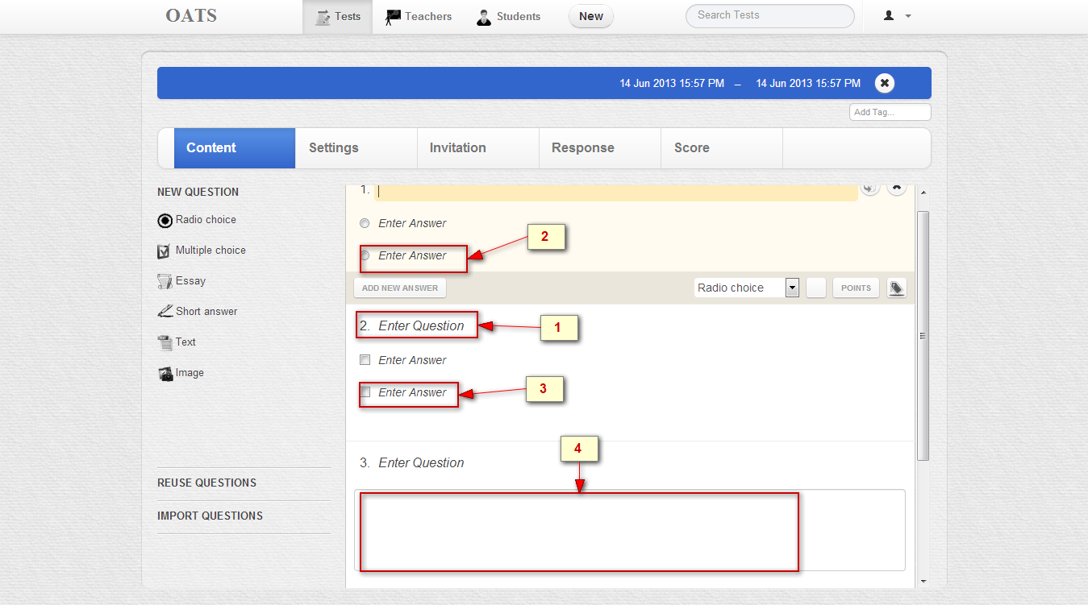

#### Objects and Actions

##### Data fields – Language Type screen

|  |  |  |  |  |  |  |
| --- | --- | --- | --- | --- | --- | --- |
| **Field No** | **Field name** | **Type** | **Mandatory** | **Data type** | **Max length** | **Description** |
| 2 | Question content | Text |  | String |  | Question content |
| 4 | Text area answer | Text |  | String |  | Text area answer |

##### Actions – Language Type screen

|  |  |  |  |  |  |
| --- | --- | --- | --- | --- | --- |
| **Field No** | **Field name** | **Type** | **Action** | **Description** | **Validation** |
| 1 | Radio question | Button | On click | Choose the answer |  |
| 3 | Multiple question | Button | On click | Choose one or any answers |  |

### SCORE ON TEST SCREEN

#### Screen Images

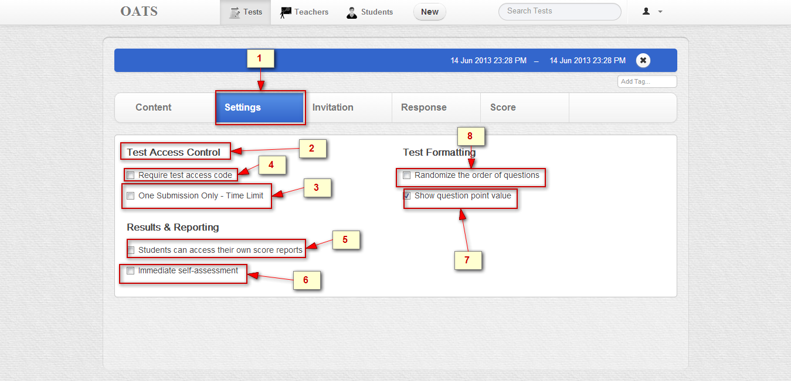

#### Objects and Actions

##### Data fields – Class page: Unit screen

|  |  |  |  |  |  |  |
| --- | --- | --- | --- | --- | --- | --- |
| **Field No** | **Field name** | **Type** | **Mandatory** | **Data type** | **Max length** | **Description** |
| 2 | Setting names | Text |  | String |  | Setting names |

##### Actions – Class page: Unit screen

|  |  |  |  |  |  |
| --- | --- | --- | --- | --- | --- |
| **Field No** | **Field name** | **Type** | **Action** | **Description** | **Validation** |
| 1 | Setting | Link | On click | Set option to fine-tune the test taker’s experience and their access to scores and reports |  |
| 3 | One submission Only – Time limit | Checkbox | Click | Limit student to review only once they submitted their test |  |
| 4 | Require test access code | Checkbox | Click | When enabled, a test specific code is generated and displayed here |  |
| 5 | Student can access own their report | Checkbox | Click | Student can only see their scores a test if it end time has passed and its option is enabled. Allows them to open past test and see their own(but only their and no others’)score report and test responses |  |
| 6 | Immediate self- assessment | Checkbox | Click | Provide students a score report on their performance right the moment they submit the test |  |
| 7 | Show question point value | Checkbox | Click | Show student the mark point of each question. |  |
| 8 | Randomize the orders of questions | Checkbox | Click | Present all questions in random order to student |  |

### TEST SETTING SCREEN

#### Screen Images

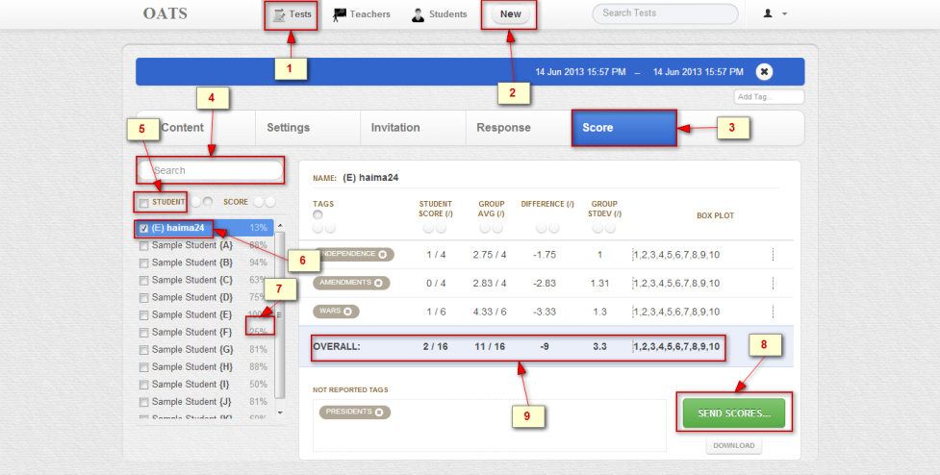

#### Objects and Actions

##### Data fields – Class page: Unit screen

|  |  |  |  |  |  |  |
| --- | --- | --- | --- | --- | --- | --- |
| **Field No** | **Field name** | **Type** | **Mandatory** | **Data type** | **Max length** | **Description** |
| 7 | Score achieved for rate percent of a student | Text |  | String |  |  |
| 9 | Overall | Text |  | String |  | Overall |

##### Actions – Class page: Unit screen

|  |  |  |  |  |  |
| --- | --- | --- | --- | --- | --- |
| **Field No** | **Field name** | **Type** | **Action** | **Description** | **Validation** |
| 1 | Test | Link | On click | Creates, modify and manages tests , test content(questions), assign students and educators , respones and scores |  |
| 2 | New | Link | On click | Create a new test |  |
| 3 | Score | Link | On click | Analyze overall and partial scores of one, all or any subset of student who took this test |  |
| 4 | Search student | Textbox | On submit | Search student |  |
| 5 | Check all students | Checkbox | Check | Choose all student |  |
| 6 | Check a student | Checkbox | Check | Choose a student |  |
| 8 | Send Score | Button | On click | Send Score |  |

### RESPONSES ON TEST SCREEN

#### Screen Images

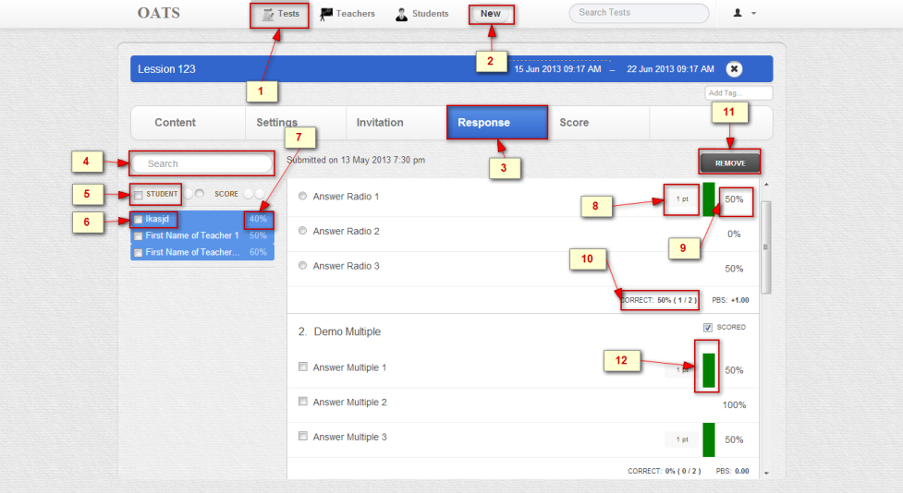

#### Objects and Actions

##### Data fields – Class page: Unit screen

|  |  |  |  |  |  |  |
| --- | --- | --- | --- | --- | --- | --- |
| **Field No** | **Field name** | **Type** | **Mandatory** | **Data type** | **Max length** | **Description** |
| 7 | Score achieved for rate percent of a student | Text |  | String |  | Score achieved for rate percent of a student |
| 8 | Mark for a question | Text |  | String |  | Mark for a question |
| 9 | Rate percent for answer of users | Text |  | String |  | Rate percent for answer of users |
| 10 | Rate percent for true answer of users | Text |  | String |  | Rate percent for true answer of users |
| 12 | Image for true answers | Image |  | Image |  | Image for true answers |

##### Actions – Class page: Unit screen

|  |  |  |  |  |  |
| --- | --- | --- | --- | --- | --- |
| **Field No** | **Field name** | **Type** | **Action** | **Description** | **Validation** |
| 1 | Test | Link | On click | Creates, modify and manages tests , test content(questions), assign students and educators , respones and scores |  |
| 2 | New | Link | On click | Create a new test |  |
| 3 | Responses | Link | On click | Review individual student response and item analytics for any subset of test responses from all or some of the students |  |
| 4 | Search student | Textbox | On submit | Search student |  |
| 5 | Check all students | Checkbox | Check | Choose all student |  |
| 6 | Check a student | Checkbox | Check | Choose a student |  |
| 11 | Remove | Button | On click | Remove a test |  |

### INVITE USERS TO TEST SCREEN

#### Screen Images

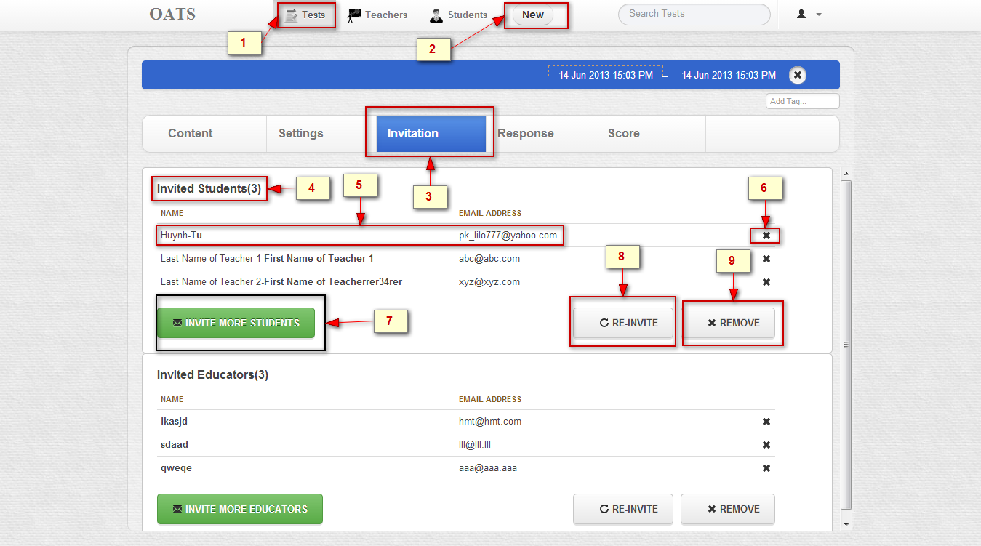

#### Objects and Actions

##### Data fields – Class page: Discussion Forum

|  |  |  |  |  |  |  |
| --- | --- | --- | --- | --- | --- | --- |
| **Field No** | **Field name** | **Type** | **Mandatory** | **Data type** | **Max length** | **Description** |
| 4 | Invited user | Text |  | String |  | Number of invited user |
| 5 | Username and email | Text |  | String |  | Username and email of invited user |

##### Actions – Class page: Discussion Forum

|  |  |  |  |  |  |
| --- | --- | --- | --- | --- | --- |
| **Field No** | **Field name** | **Type** | **Action** | **Description** | **Validation** |
| 1 | Test | Link | On click | Creates, modify and manages tests , test content(questions), assign students and educators , respones and scores |  |
| 7 | Invite more users | Button | On click | Invites more users |  |
| 8 | Reinvite more users | Button | On click | Reinvites users invited |  |
| 9 | Remove users | Button | On click | Remove users |  |
| 2 | New | Link | On click | Create a new test |  |
| 6 | Delete user | Button | On click | Delete user |  |
| 3 | Invitation | Link | On click | Control who can access this test with student and teacher invitations |  |

### 

### ASSIGN TESTS TO STUDENT SCREEN

#### Screen Images

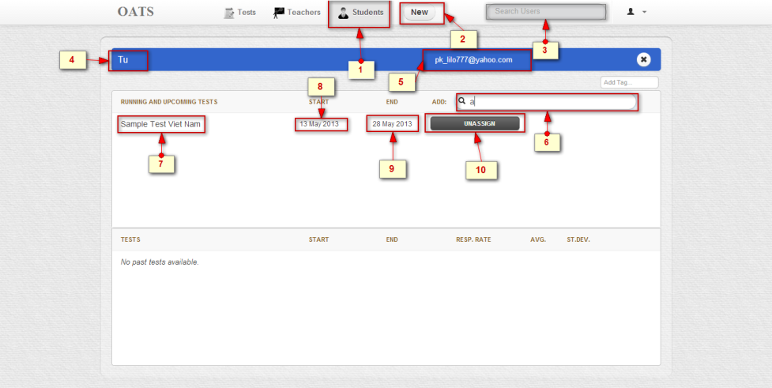

#### Objects and Actions

##### Data fields – Unit Lesson Screen

|  |  |  |  |  |  |  |
| --- | --- | --- | --- | --- | --- | --- |
| **Field No** | **Field name** | **Type** | **Mandatory** | **Data type** | **Max length** | **Description** |
| 4 | Student’s user name | Text |  | String |  | Student’s user name |
| 5 | Student’s user email | Text |  | String |  | Student’s user email |
| 7 | Test’s name | Text |  | String |  | Test’s name |
| 8 | Start date | Text |  | Date |  | Start date |
| 9 | End date | Text |  | Date |  | End date |

##### Actions – Unit Lesson Screen

|  |  |  |  |  |  |
| --- | --- | --- | --- | --- | --- |
| **Field No** | **Field name** | **Type** | **Action** | **Description** | **Validation** |
| 2 | New | Link | On click | Create a new Student |  |
| 3 | Search Student | Textbox | On submit | Searcher Student |  |
| 10 | Unassign a test | Button | On submit | Remove a test |  |
| 6 | Search test | Textbox | On submit | Searcher test |  |
| 1 | Student | Link | On click | Create , modify and look up student login and assign them to test to collaborate |  |

### ASSIGN TESTS TO TEACHER SCREEN

#### Screen Images

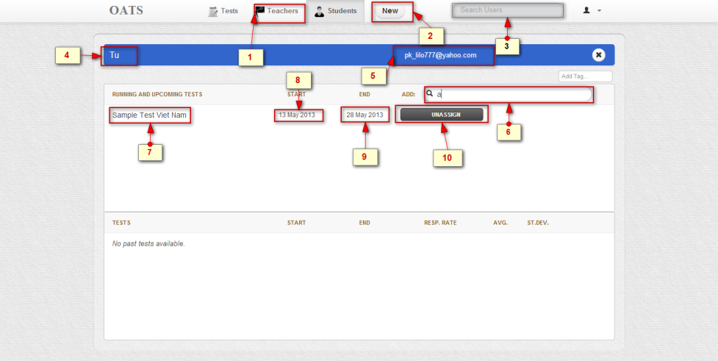

#### Objects and Actions

##### Data fields – Unit Quiz Screen

|  |  |  |  |  |  |  |
| --- | --- | --- | --- | --- | --- | --- |
| **Field No** | **Field name** | **Type** | **Mandatory** | **Data type** | **Max length** | **Description** |
| 4 | Teacher’s user name | Text |  | String |  | Teacher’s user name |
| 5 | Teacher’s user email | Text |  | String |  | Teacher’s user email |
| 7 | Test’s name | Text |  | String |  | Test’s name |
| 8 | Start date | Text |  | Date |  | Start date |
| 9 | End date | Text |  | Date |  | End date |

##### Actions – Unit Lesson Screen

|  |  |  |  |  |  |
| --- | --- | --- | --- | --- | --- |
| **Field No** | **Field name** | **Type** | **Action** | **Description** | **Validation** |
| 1 | Teacher | Link | On click | Create , modify and look up teacher login and assign them to test to collaborate |  |
| 2 | New | Link | On click | Create a new teacher |  |
| 3 | Search teacher | Textbox | On submit | Searcher teacher |  |
| 10 | Unassign a test | Button | On submit | Remove a test |  |
| 6 | Search test | Textbox | On submit | Searcher test |  |

### DO TEST SCREEN

#### Screen Images

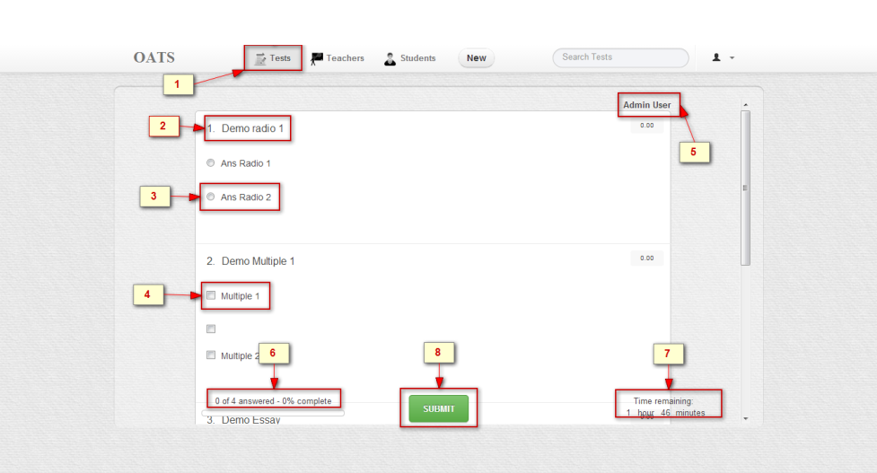

#### Objects and Actions

##### Data fields – Unit Quiz Screen

|  |  |  |  |  |  |  |
| --- | --- | --- | --- | --- | --- | --- |
| **Field No** | **Field name** | **Type** | **Mandatory** | **Data type** | **Max length** | **Description** |
| 2 | Question | Text |  | String |  | Question's content |
| 3 | Answer Radio List | List |  | Object |  | List of questions belong to one question |
| 4 | Answer Multiple List | List |  | Object |  | List of questions belong to one question |
| 5 | User |  |  | Object |  |  |
| 6 | Number of Answer and number of question | Text |  | String |  | Answer number and question number |
| 7 | Time remaining | Text |  | Date |  | Time remaining |
| 7 | Answer List | List |  | Object |  | List of questions belong to one question |

##### Actions – Unit Lesson Screen

|  |  |  |  |  |  |
| --- | --- | --- | --- | --- | --- |
| **Field No** | **Field name** | **Type** | **Action** | **Description** | **Validation** |
| 1 | Test | Link | On click | Creates, modify and manages tests , test content(questions), assign students and educators , respones and scores |  |
| 8 | Submit | Button | On click | Submit user answer to server |  |

## DATABASE DESIGN

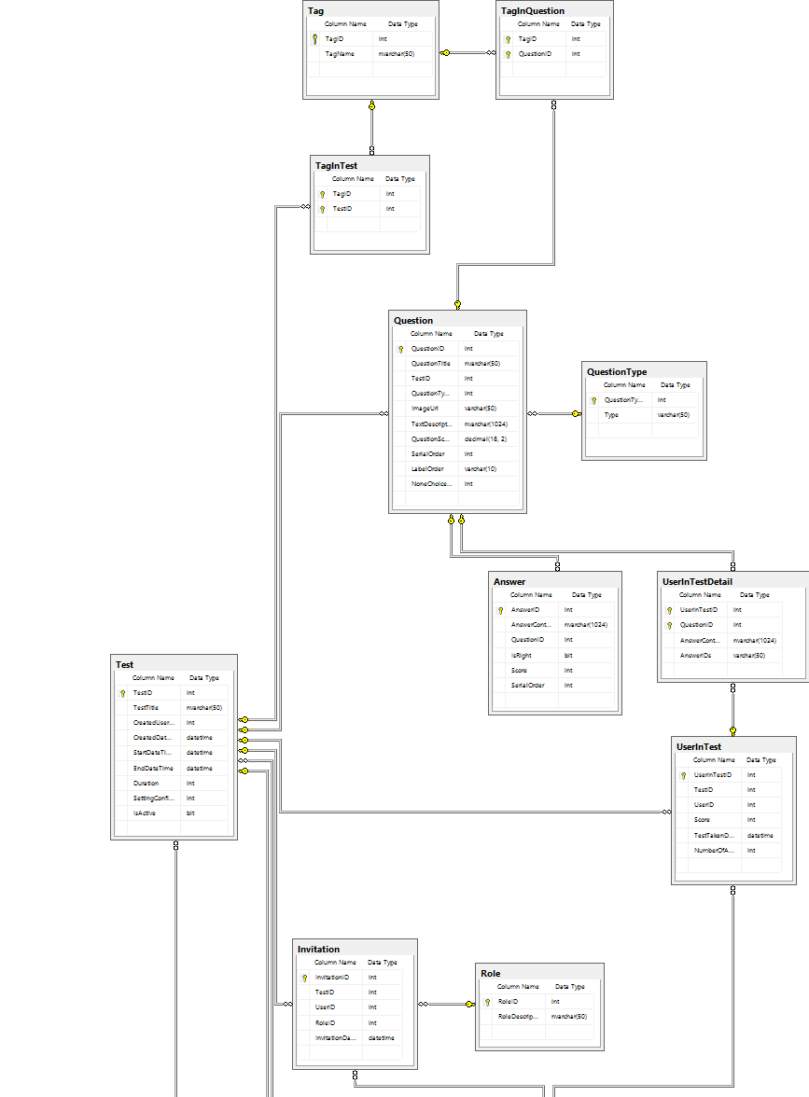

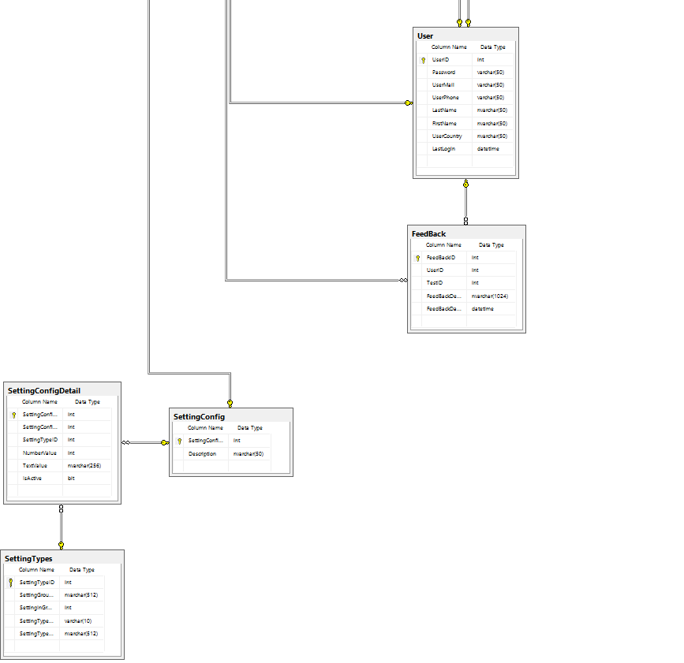

|  |
| --- |
| **Table Test** |
| |  |  |  |  |  |  | | --- | --- | --- | --- | --- | --- | | **Field** | **Type** | **Null** | **Key** | **Default** | **Extra** | | TestID | int | NO | PK |  | auto_increment | | TestTitle | nvarchar(50) | NO |  |  |  | | CreatedUserID | int | NO |  |  |  | | CreatedDateTime | datetime | NO |  |  |  | | StartDateTime | datetime | NO |  |  |  | | EndDateTime | datetime | YES |  |  |  | | Duration | int | YES |  |  |  | | SettingConfigID | int | YES |  |  |  | | IsActive | bit | NO |  |  |  | |
| **Table Invitation** |
| |  |  |  |  |  |  | | --- | --- | --- | --- | --- | --- | | Field | Type | Null | Key | Default | Extra | | InvitationID | int | NO | PK |  | auto_increment | | TestID | int | NO | FK |  |  | | UserID | int | NO | FK |  |  | | RoleID | int | YES | FK |  |  | | InvitationDateTime | datetime | YES |  |  |  | |
| **Table Tag** |
| |  |  |  |  |  |  | | --- | --- | --- | --- | --- | --- | | Field | Type | Null | Key | Default | Extra | | TagID | int | NO | PK |  | auto_increment | | TagName | Nvarchar(50) | NO |  |  |  | |
| **Table TagInTest** |
| |  |  |  |  |  |  | | --- | --- | --- | --- | --- | --- | | Field | Type | Null | Key | Default | Extra | | TagID | int | NO | PK,FK |  |  | | TestID | int | NO | PK,FK |  |  | |
| **Table TagInQuestion** |
| |  |  |  |  |  |  | | --- | --- | --- | --- | --- | --- | | Field | Type | Null | Key | Default | Extra | | TagID | int | NO | PK,FK |  |  | | QuestionID | int | NO | PK,FK |  |  | |
| **Table Question** |
| |  |  |  |  |  |  | | --- | --- | --- | --- | --- | --- | | Field | Type | Null | Key | Default | Extra | | QuestionID | int | NO | PK |  | auto_increment | | QuestionTitle | nvarchar(50) | NO |  |  |  | | TestID | int | NO | FK |  |  | | QuestionTypeID | int | NO | FK |  |  | | ImageUrl | varchar(50) | YES |  |  |  | | TextDescription | nvarchar(1024 | YES |  |  |  | | QuestionScore | decimal(18, 2) | NO |  |  |  | | SerialOrder | int | YES |  |  |  | | LabelOrder | varchar(10) | YES |  |  |  | | NoneChoiceScore | int | YES |  |  |  | |
| **Table QuestionType** |
| |  |  |  |  |  |  | | --- | --- | --- | --- | --- | --- | | Field | Type | Null | Key | Default | Extra | | QuestionTypeID | int | NO | PK |  | auto_increment | | Type | varchar(50) | NO |  |  |  | |
| **Table Answer** |
| |  |  |  |  |  |  | | --- | --- | --- | --- | --- | --- | | Field | Type | Null | Key | Default | Extra | | AnswerID | int | NO | PK |  | auto_increment | | AnswerContent | nvarchar(1024) | NO |  |  |  | | QuestionID | int | NO | FK |  |  | | IsRight | bit | NO |  |  |  | | Score | int | YES |  |  |  | | SerialOrder | int | YES |  |  |  | |
| **Table UserInTest**   |  |  |  |  |  |  | | --- | --- | --- | --- | --- | --- | | Field | Type | Null | Key | Default | Extra | | UserInTestID | int | NO | PK |  | auto_increment | | TestID | int | NO | FK |  |  | | UserID | int | NO | FK |  |  | | Score | int | NO |  |  |  | | TestTakenDate | datetime | YES |  |  |  | | NumberOfAttend | int | NO |  |  |  | |
| **Table UserInTestDetail**   |  |  |  |  |  |  | | --- | --- | --- | --- | --- | --- | | Field | Type | Null | Key | Default | Extra | | UserInTestID | int | NO | PK,FK |  |  | | QuestionID | int | NO | PK,FK |  |  | | AnswerContent | nvarchar(1024) | YES |  |  |  | | AnswerIDs | varchar(50) | YES |  |  |  | |
|  |
| **Table Role** |
| |  |  |  |  |  |  | | --- | --- | --- | --- | --- | --- | | Field | Type | Null | Key | Default | Extra | | RoleID | int | NO | PK |  | auto_increment | | RoleDescription | nvarchar(50) | NO |  |  |  | |
| **Table User** |
| |  |  |  |  |  |  | | --- | --- | --- | --- | --- | --- | | Field | Type | Null | Key | Default | Extra | | UserID | int | NO | PK |  | auto_increment | | Password | varchar(50) | YES |  |  |  | | UserMail | varchar(50) | NO |  |  |  | | UserPhone | varchar(50) | YES |  |  |  | | LastName | varchar(50) | YES |  |  |  | | FirstName | varchar(50) | YES |  |  |  | | UserCountry | varchar(50) | YES |  |  |  | | LastLogin | datetime | YES |  |  |  | |
| **Table FeedBack** |
| |  |  |  |  |  |  | | --- | --- | --- | --- | --- | --- | | Field | Type | Null | Key | Default | Extra | | FeedBackID | int | NO | PK |  | auto_increment | | UserID | int | NO | FK |  |  | | TestID | int | NO | FK |  |  | | FeedBackDetail | nvarchar(1024) | YES |  |  |  | | FeedBackDateTime | datetime | YES |  |  |  | |

|  |
| --- |
| **Table SettingConfig** |
| |  |  |  |  |  |  | | --- | --- | --- | --- | --- | --- | | Field | Type | Null | Key | Default | Extra | | SettingConfigID | int | NO | PK |  | auto_increment | | Description | nvarchar(50) | YES |  |  |  | |

|  |
| --- |
| **Table SettingConfigDetail** |
| |  |  |  |  |  |  | | --- | --- | --- | --- | --- | --- | | Field | Type | Null | Key | Default | Extra | | SettingConfigDetailID | int | NO | PK |  | auto_increment | | SettingConfigID | int | NO | FK |  |  | | SettingTypeID | int | NO | FK |  |  | | NumberValue | int | YES |  |  |  | | TextValue | nvarchar(256) | YES |  |  |  | | IsActive | bit | NO |  |  |  | |

|  |
| --- |
| **Table SettingTypes** |
| |  |  |  |  |  |  | | --- | --- | --- | --- | --- | --- | | Field | Type | Null | Key | Default | Extra | | SettingTypeID | int | NO | PK |  | auto_increment | | SettingGroupName | nvarchar(512) | YES |  |  |  | | SettingInGroupOrder | int | YES |  |  |  | | SettingTypeKey | varchar(10) | NO |  |  |  | | SettingTypeDescription | nvarchar(512) | YES |  |  |  | |